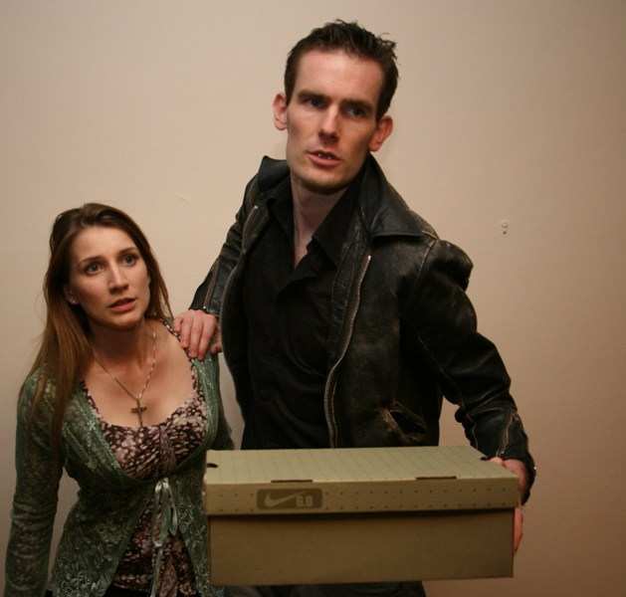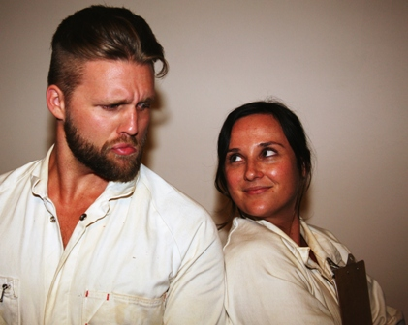

For immediate release
FACTORY SPACE THEATRE COMPANY PRESENTS

After Easter
Written by prize winning playwright Anne Devlin
Directed by Roz Riley

(12th April to 3rd May, 2014)

Greta is protesting. Meanwhile, her husband is cheating. And her family thinks she’s just a little bit crazy.
Perhaps they’re right. After all, she is having visions, despite being an atheist. But they aren’t much better off. One sister is married, unhappily. The other won’t marry at all. Their brother is married to his art. Their cousin is married to God. And Dad’s dead, but he still has a lot to say.
A journey to the heart of an unravelling family – with a little fishing and shootin’ along the way.

- Directed by Roz Riley
- Opening Night –at the Star of the Sea Theatre, Manly
- Playing – Fri & Sat 7.30 evenings, and Sun 3pm matinees, 12-13 April, 25-27 April & 2-3 May
- Tickets $35/$28 from trybooking.com or 94391906
- Cast: Mitchell Cox, Ciaran Daly, Eilannin Dhu, Imogen French, Laura Gailbraith, William Jordan, Celia Kelly, Karoline Rose O’Sullivan and Ros Richards.
- This is the first play of Factory Space’s 2014 season, which will span three productions. This is the 14th year of professional productions for the Factory Space Theatre Company – and the fifth as resident company at Star of the Sea.

For further information or press queries please email Roz at factoryspacetheatre@gmail.com or call (02) 9439 1906
Additional photos available upon request

www.factoryspace.org

